Tab 1

**Restaurant Manager – Family Business** *Orivesi & Tampere, Finland*

I managed my family’s restaurant, starting in a small town in Orivesi before we moved and grew the business in Tampere. Working side by side with my father, I learned every part of what makes a restaurant run — from organizing schedules and managing supplies to creating a welcoming atmosphere for every guest who walked through the door.

As the restaurant expanded, I took on a bigger leadership role, supervising staff, coordinating daily operations, and making sure everything ran smoothly, even on the busiest nights. I also handled our supplier relationships and kept a close eye on inventory to make sure we balanced quality with efficiency.

Beyond the day-to-day work, I enjoyed being involved in the creative and social side of the business. I helped plan and host special events, from family gatherings to local celebrations, managing all the details to ensure each one felt special. I also promoted the restaurant through local community engagement and social media, building relationships that helped attract new customers and keep regulars coming back.

This experience taught me the real value of teamwork, chhhhhommunication, and adaptability. Managing a family restaurant gave me not only practical business and leadership skills but also a deep appreciation for hospitality and connecting with people.

<https://eat.fi/en/tampere/zaiqa-pakistan>

Newspaper of Orivesi also published us back in 2016

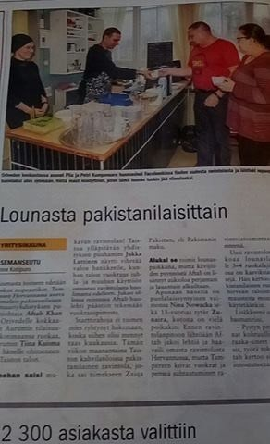

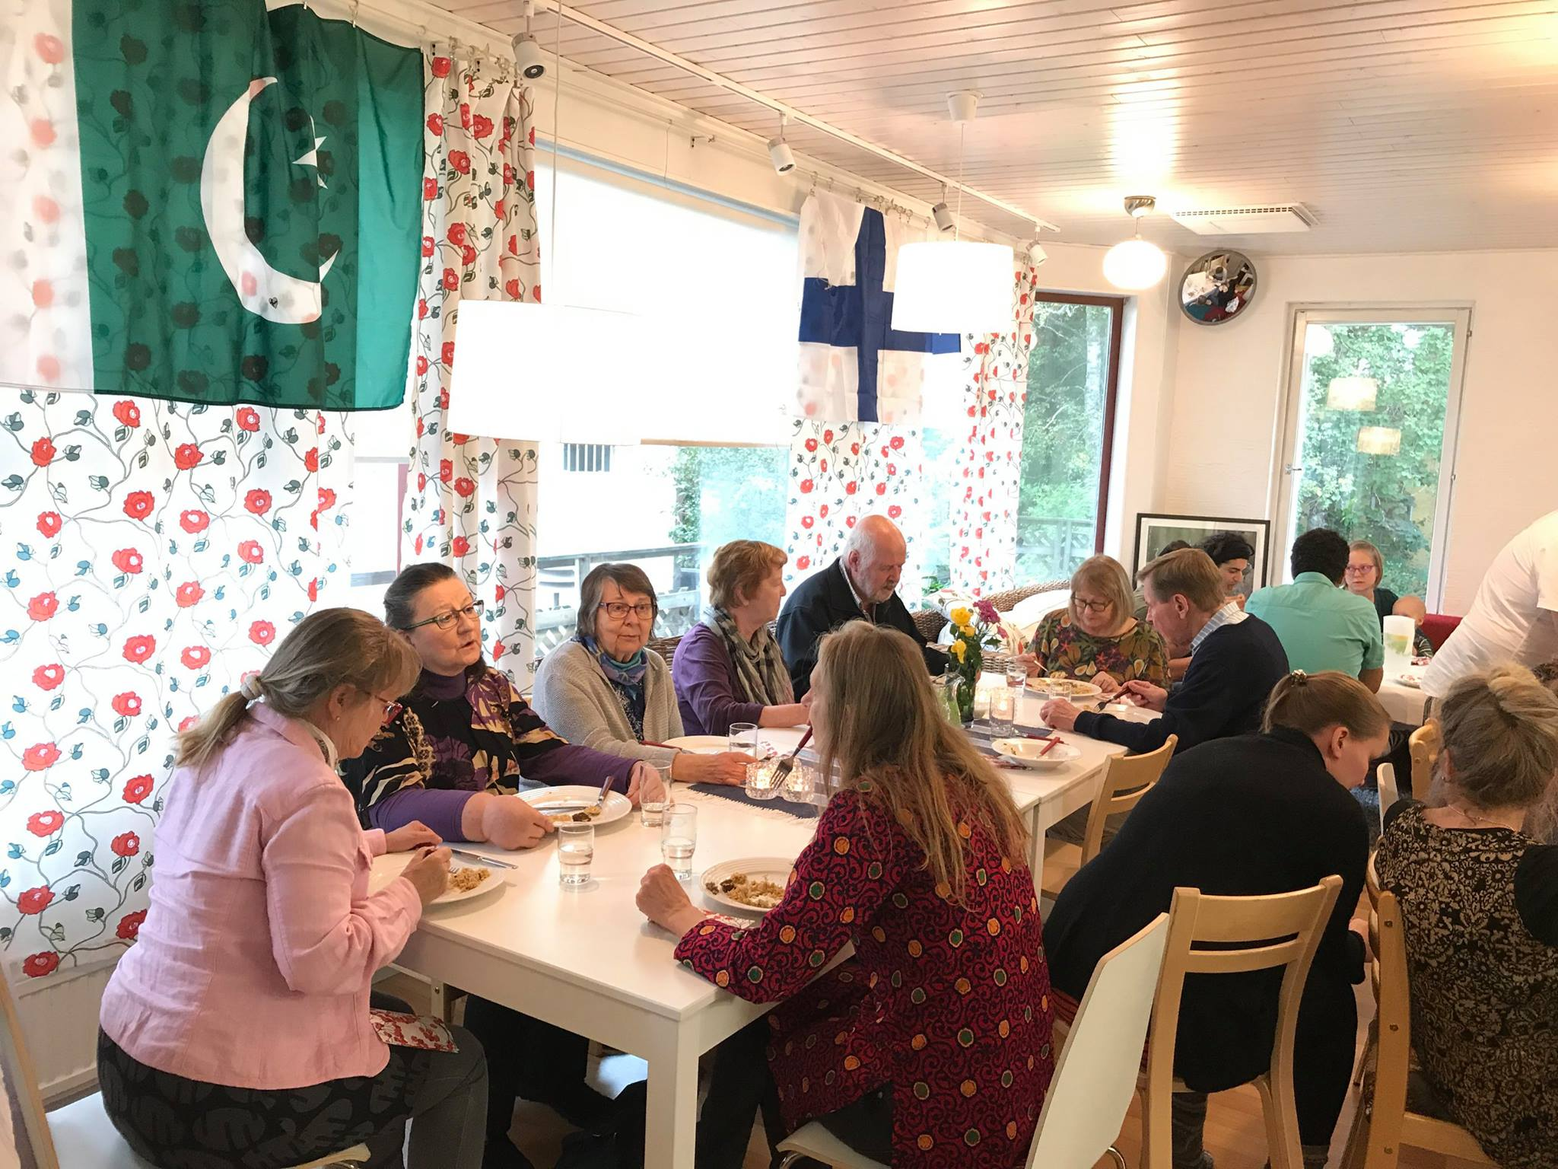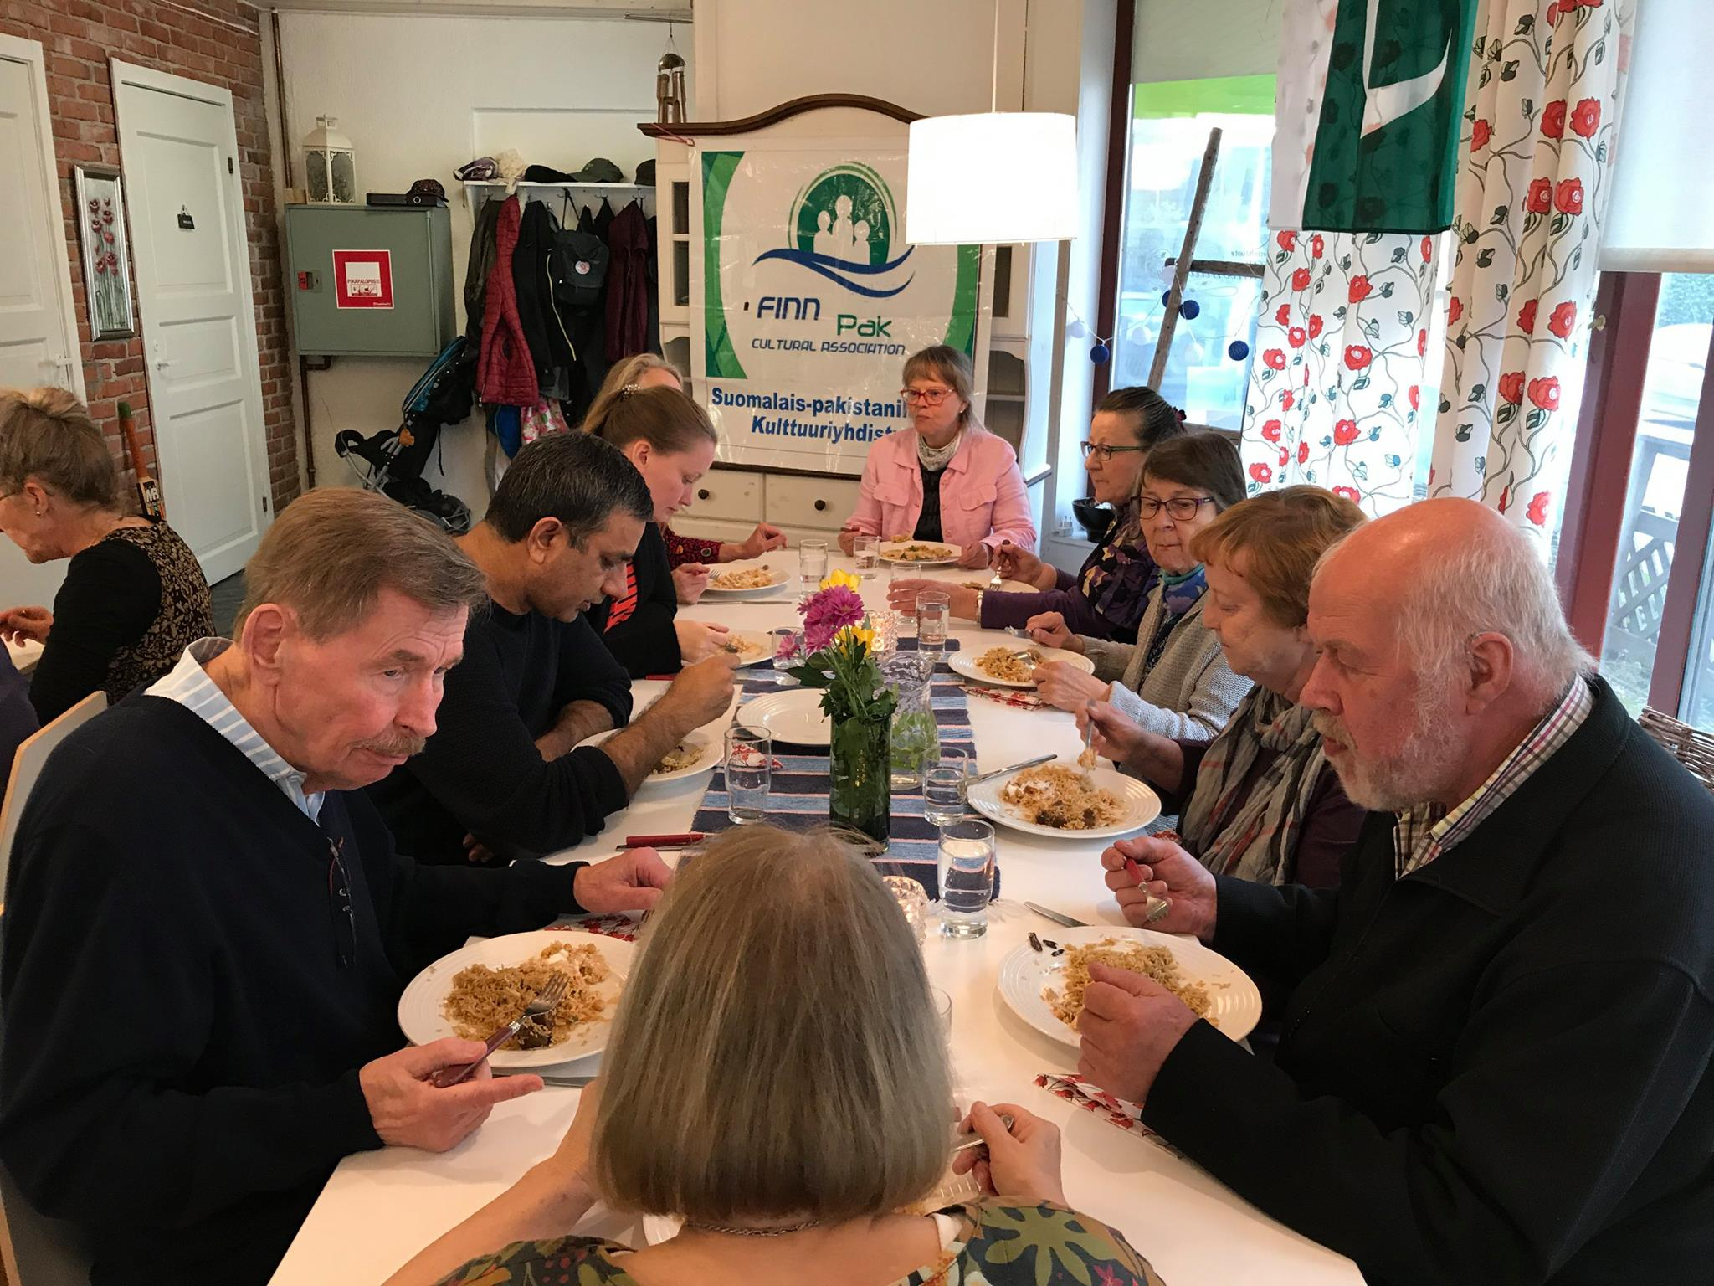

Tab 2

**Customer Service Representative — Helinä Rautavaara Museum**

In this role, I was dedicated to delivering excellent customer service and ensuring every visitor had a welcoming and memorable experience. I coordinated and managed a wide range of museum events, including cultural programs, workshops, and exhibitions, overseeing scheduling, logistics, and communication with participants to ensure smooth execution.

Beyond event management, I actively contributed to the museum’s marketing and outreach efforts. I developed and implemented promotional strategies, created engaging content, and captured photos and videos for social media platforms, which helped increase visitor engagement and broaden the museum’s online presence.

This position required strong communication, organizational, and marketing skills, as well as the ability to multitask and adapt in a dynamic, visitor-focused environment. Through this experience, I gained valuable insights into cultural programming, audience engagement, and the importance of creating meaningful experiences for diverse audiences.

[Helinä Rautavaaran museo (@helinamuseo) • Instagram photos and videos](https://www.instagram.com/helinamuseo/?igsh=MjlpODlmNmJsb2pk#)

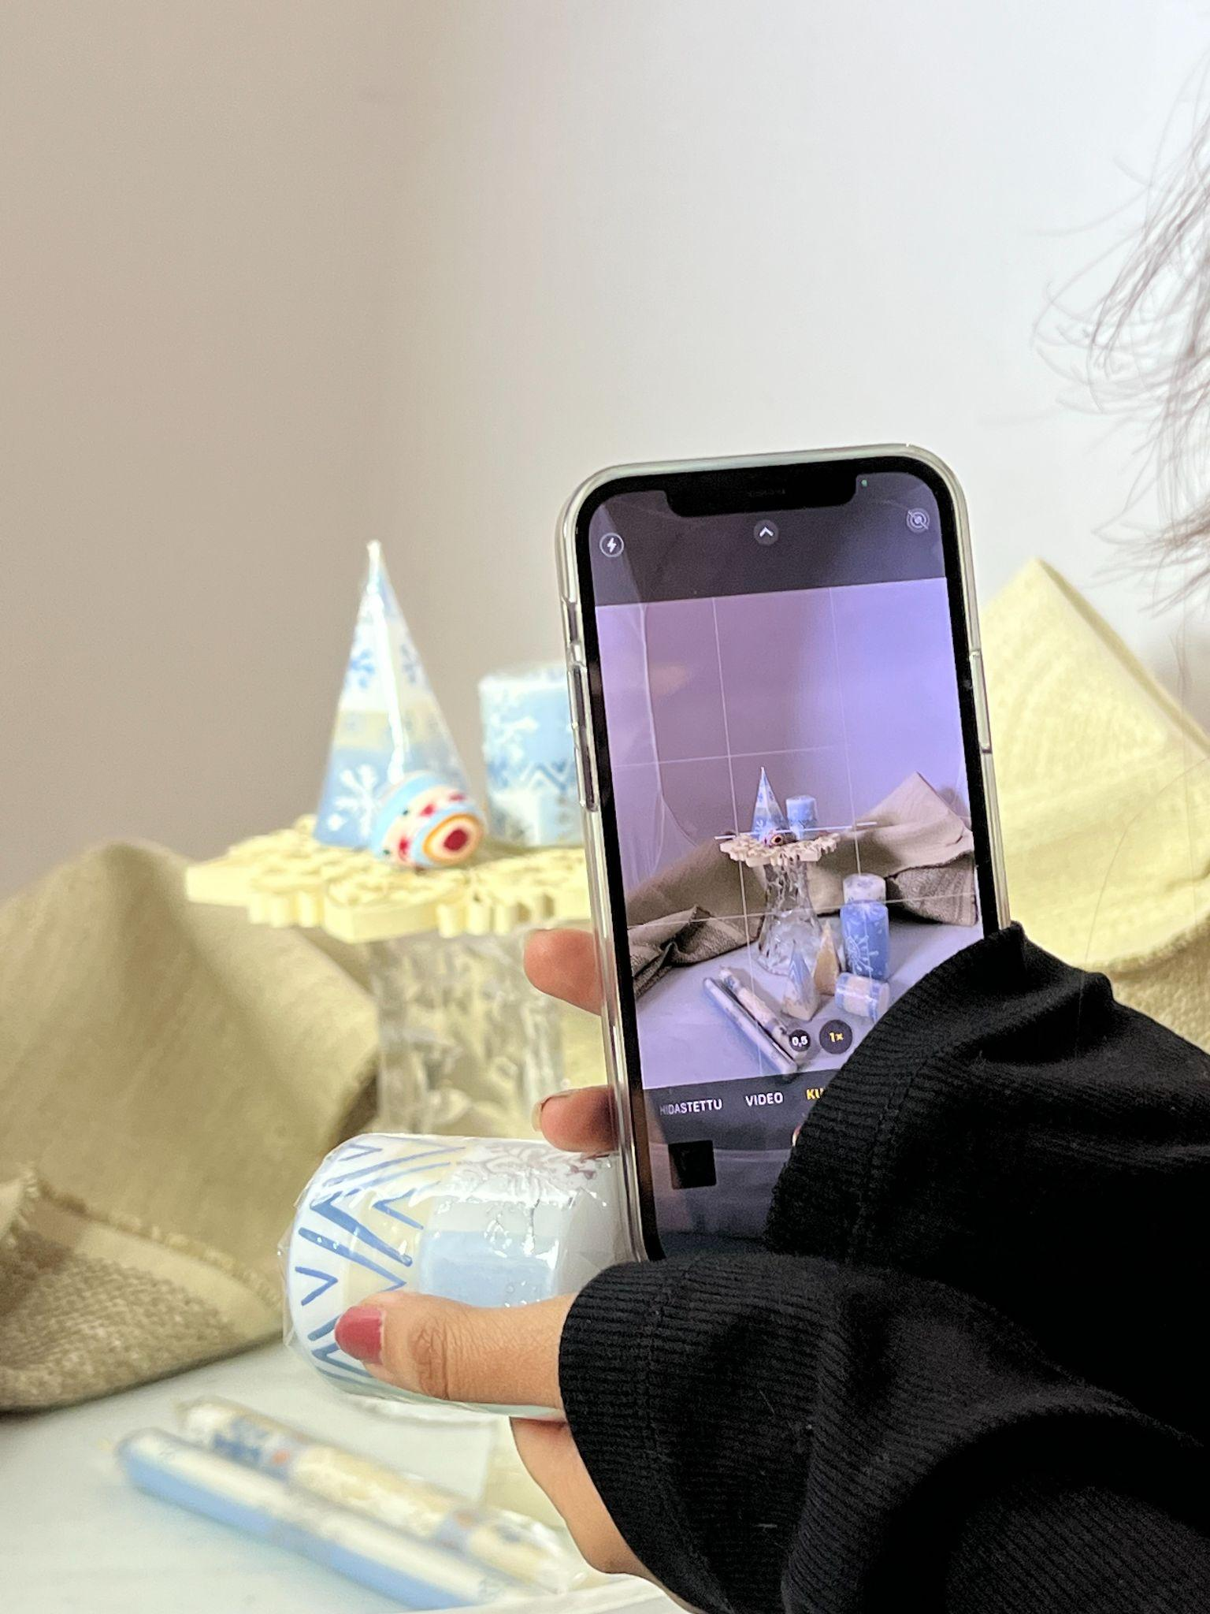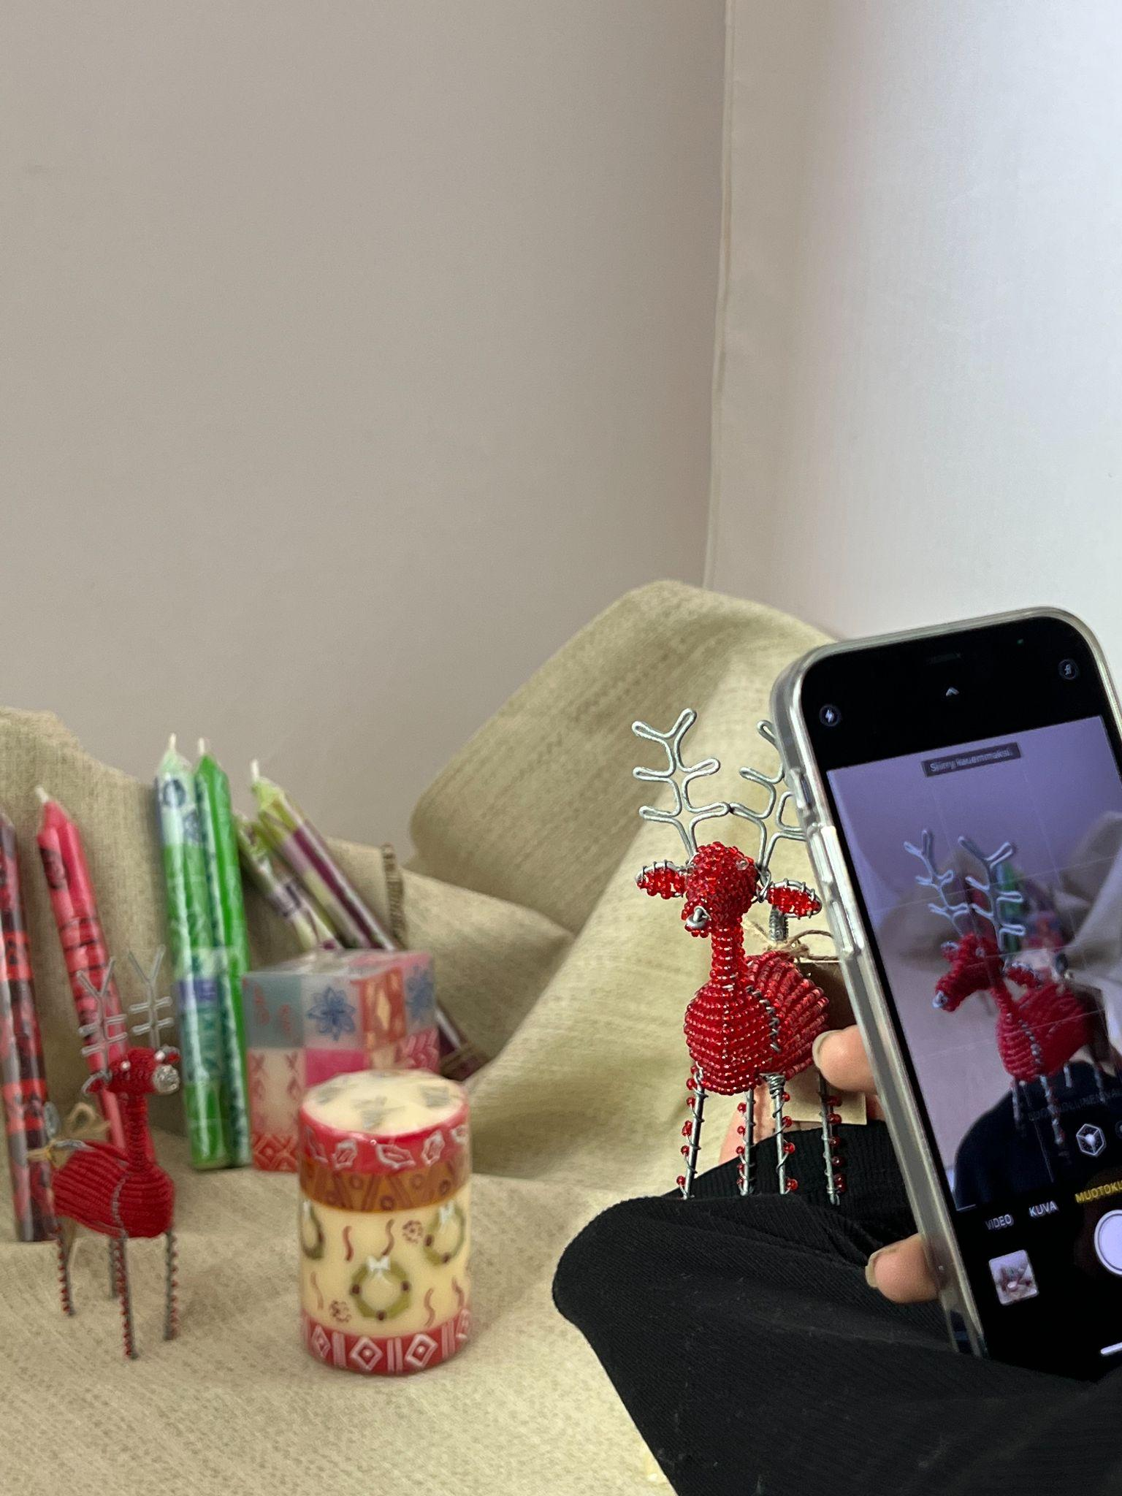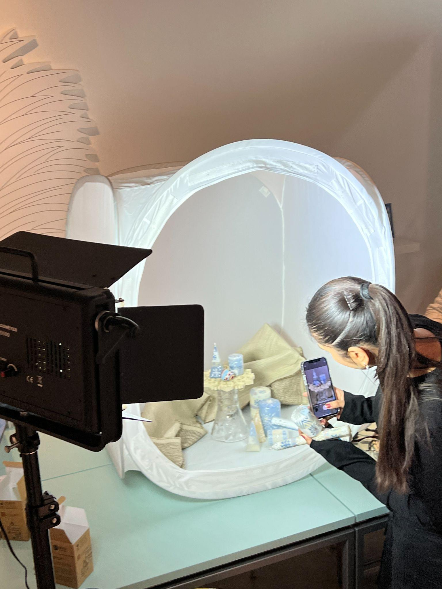

Tab 3

**Network Marketing Representative — Essence Tribe (in collaboration with Chogan, Italy)**

As part of Essence Tribe, I worked to promote and sell Chogan’s Italian-made perfumes and personal care products through direct marketing and online engagement. My role focused on building genuine relationships with customers, understanding their preferences, and recommending products that matched their individual needs.

I developed and implemented marketing strategies to increase brand visibility, using social media and word-of-mouth promotion to reach new audiences. I also collaborated closely with team members to organize online campaigns, product launches, and promotional events, helping the business grow its customer base and meet sales goals.

This experience strengthened my communication, networking, and marketing skills, while teaching me how to engage audiences authentically and drive sales through trust-based relationships.

[Essence Tribe - Network Marketing Community (@essencetribe.network) • Instagram photos and videos](https://www.instagram.com/essencetribe.network/?igsh=OGJ2b2l0bWpzNDh5#)

[Chogan Group S.p.a. - Official website - MLM - Network marketing - Multi-Level Marketing - Networker - Network Marketing](https://www.chogangroupspa.com/)

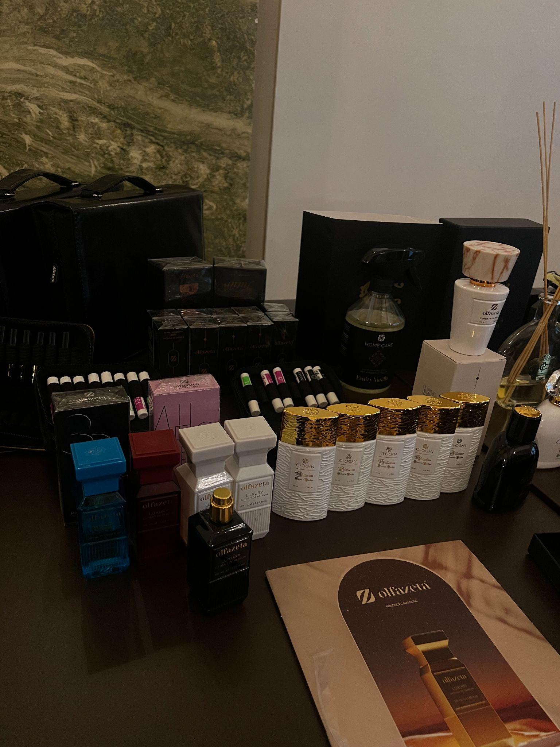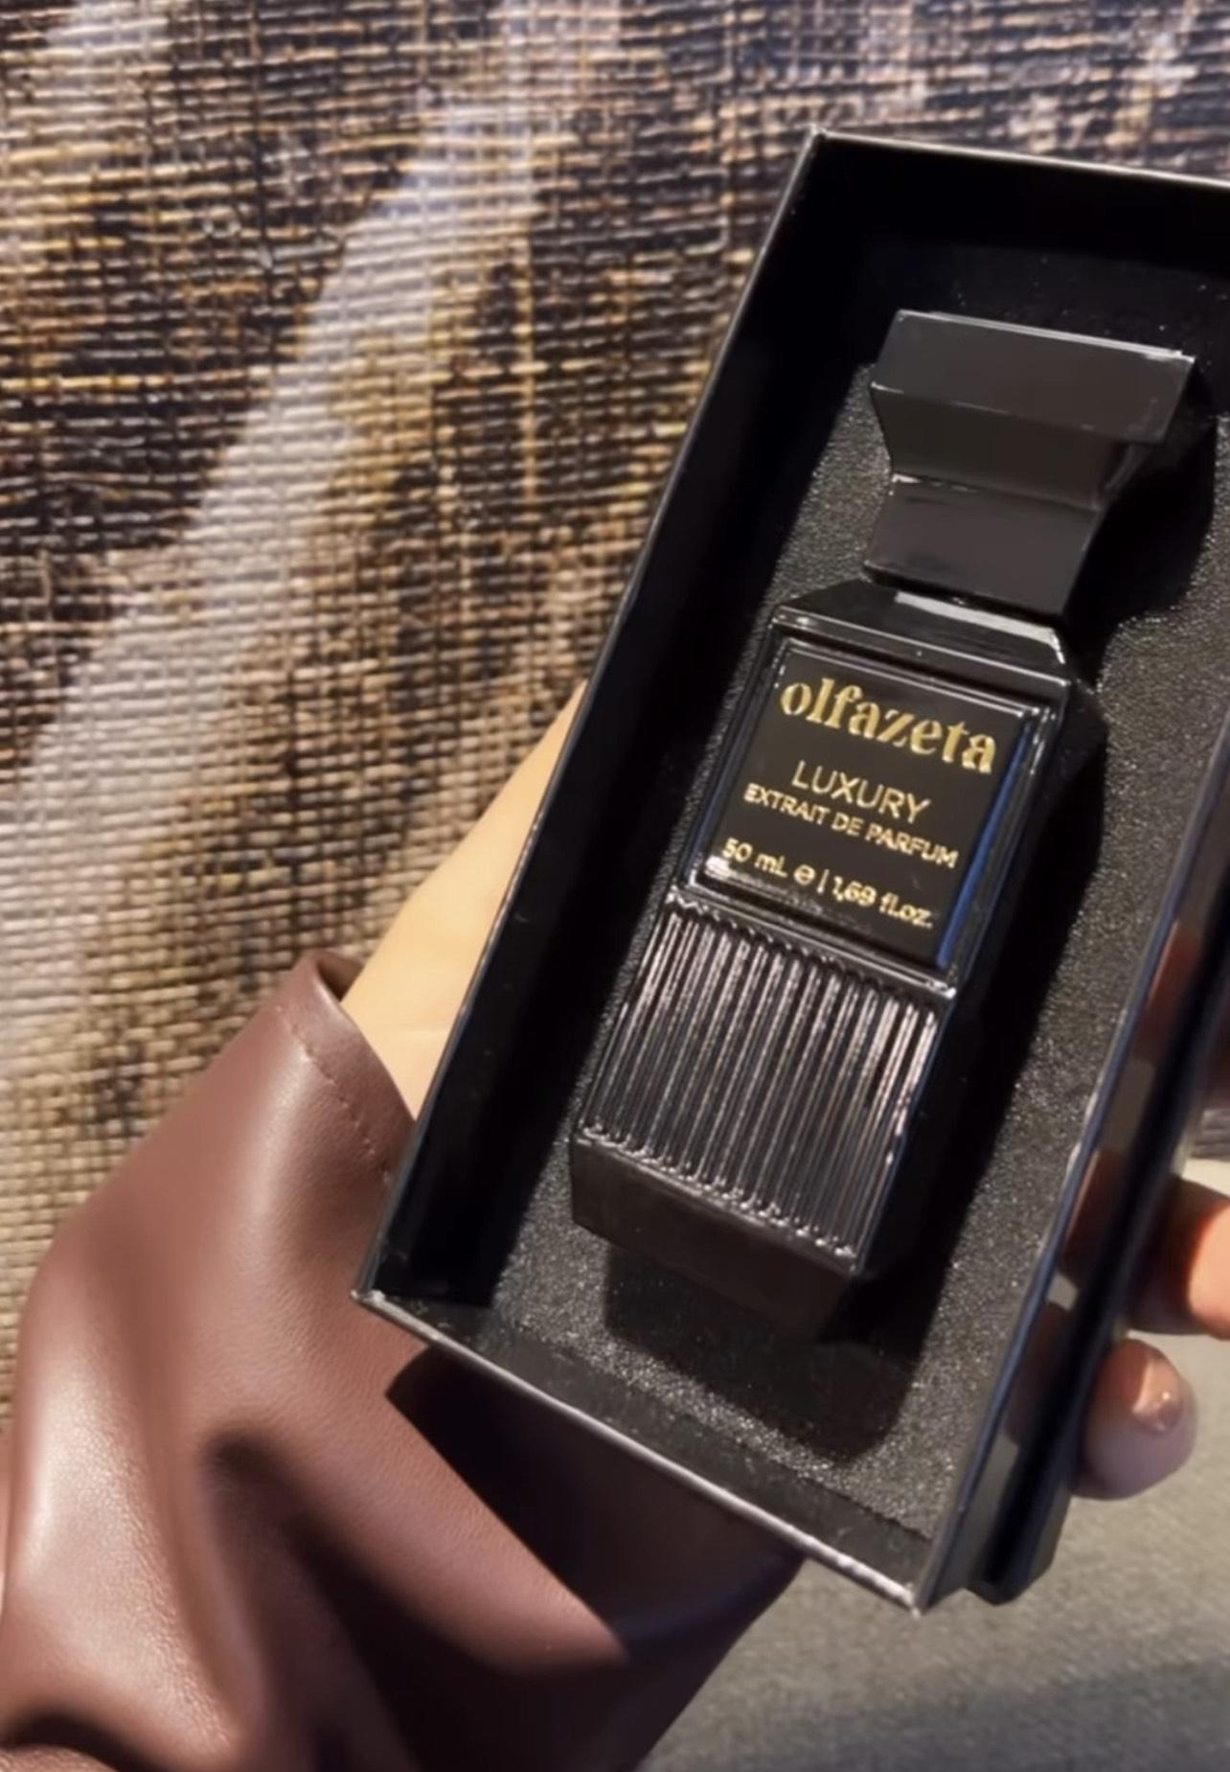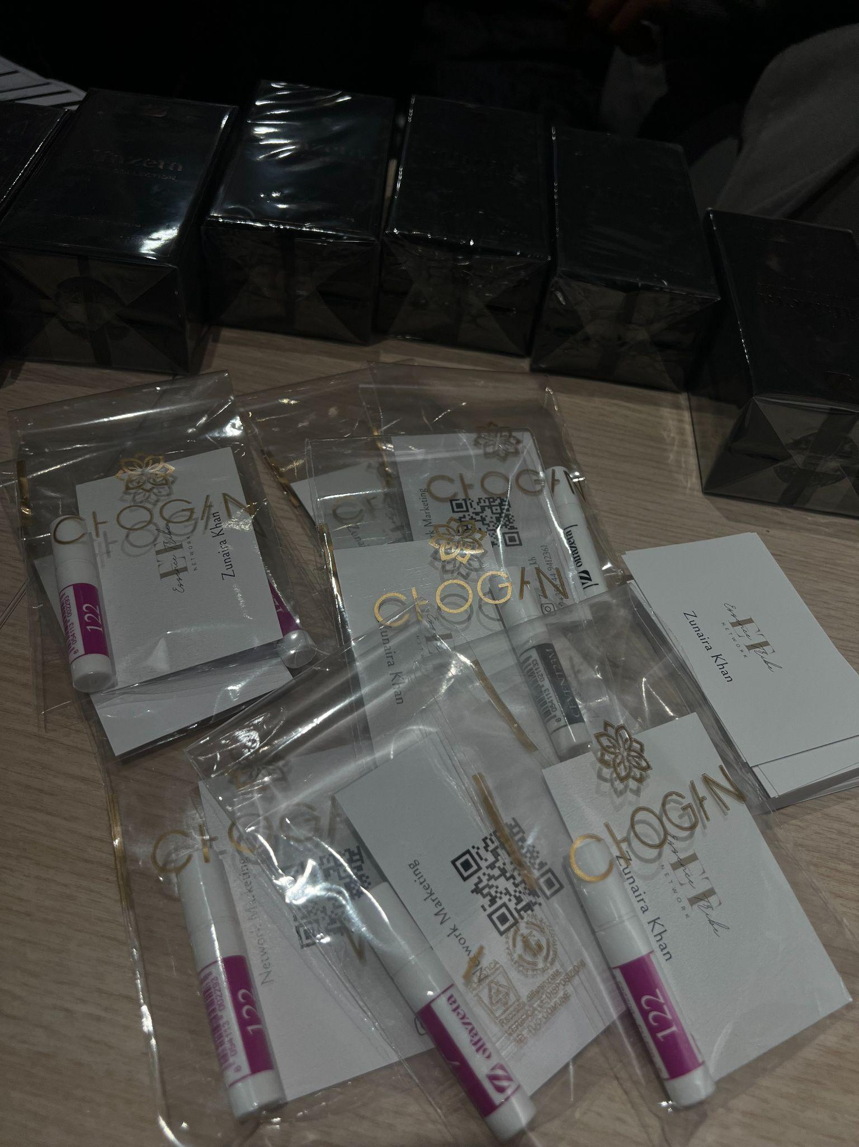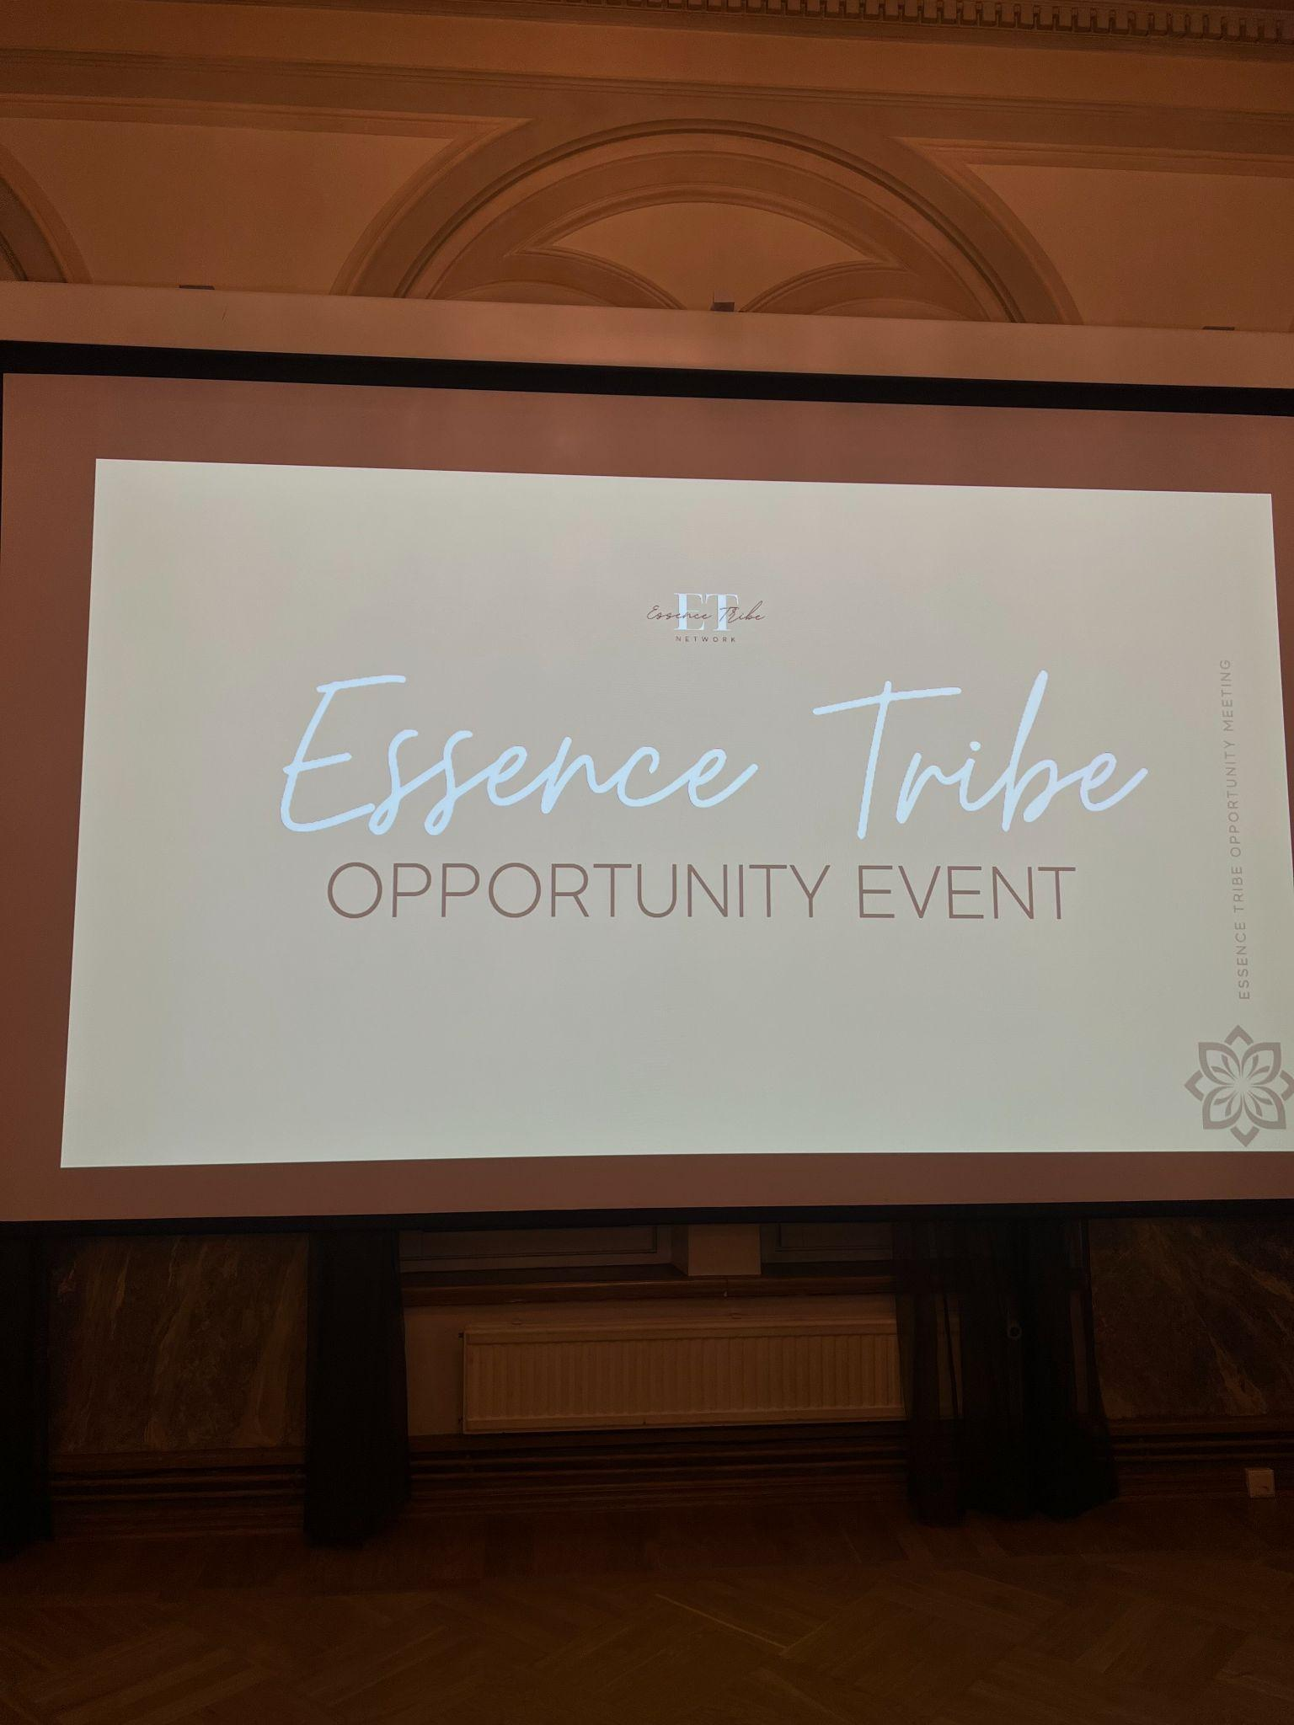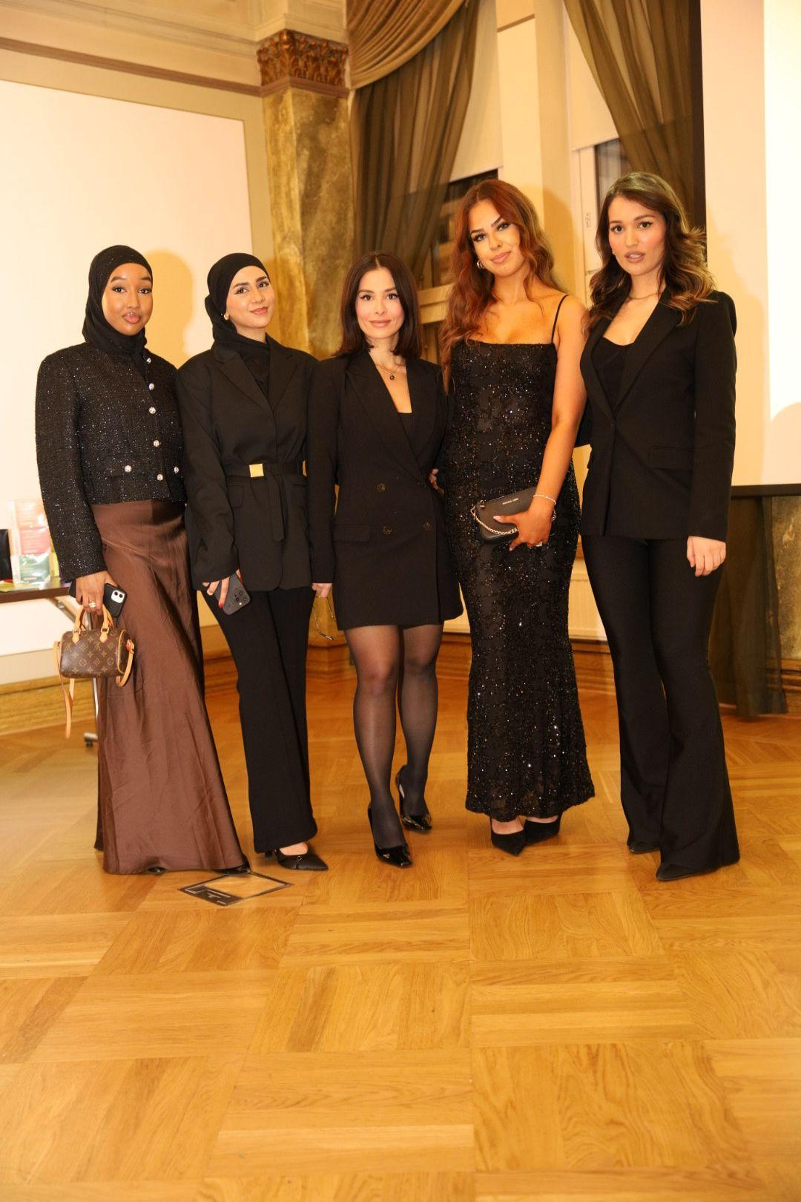

Tab 4

**Social Media & Marketing Manager — Aalto Muslim Organization (AAMU)**

As the Social Media and Marketing Manager for AAMU, I was responsible for shaping and maintaining the organization’s online presence and public communication. My role combined creativity with strategy — I planned and executed marketing campaigns, developed digital content, and managed the organization’s social media platforms, particularly Instagram.

I regularly captured and edited photos and videos to highlight community events, student activities, and cultural initiatives, helping to strengthen AAMU’s visibility and sense of community both on and off campus. I also collaborated with the event team to organize and promote gatherings, ensuring effective communication and smooth coordination from planning through to execution.

This position allowed me to develop strong skills in digital marketing, content creation, and event coordination, while deepening my understanding of communication in a diverse and multicultural environment. Through this experience, I learned how to combine creativity, organization, and cultural awareness to engage audiences and build meaningful connections online.

[Aalto Muslim Association (@aaltoaamu) • Instagram photos and videos](https://www.instagram.com/aaltoaamu/?igsh=MWowbHR6MmUzbGkwNQ%3D%3D#)

Tab 5